Ying Pei A13595990

Ricci Lam A12992490

Section A55

04/16/2017

**Lab 1: Introduction to Analog Electronics**

**Introduction:** This lab demonstrated the basics of circuit analysis using laws of circuits and then illustrated the basics of circuit design using different circuit elements, including breadboards, circuit components, and other equipment. Finally, this lab provided a summary of voltage dividers and their use in digital signals.

**Procedure:**

**A.** Design of a Voltage Reference Circuit

* Complete the Prelab and determine the resistance values and ratio of the two resistors
* Obtain four resistors of the same resistance, and verify their resistances using a multimeter
* Construct the circuit by putting resistors in series and connecting the power supply with two +5 V output and measured the branch $V_{out}$
* Change the circuit using a 4V input and connect to a parallel loading resistor from the output to the ground.
* Calculate $V_{out}$ given the value of $R_{load}$ and recalculate different values of $R_{load}$. Record the values and plot them of Voltage against Current.

**B.** Design of a Voltage divider for Digital Signals

* Obtain two 100 k $Ω$ resistors
* Set the function generator to give a 0 to +5 V square wave at a frequency of 10 kHz.
* Obtain and connect O-scope lead to the machine and red lead of the function generator cable
* Utilize the function generator to connect between the function generator and connect the black lead back to the O-scope cable.
* Makes sure it makes a square wave on the display
* Connect the leads on the generator to each end of the circuit. The O-scope lead connects to the $V_{out}$, and the black lead to the ground
* Zoom in and scale the graph to acquire a better curvature and concavity
* Find the rise and fall times of the signal by setting the signal voltage to V1 = 10 % and V2 = 90% out.

**Circuit Diagrams:**

Diagram of Circuit Without any Parallel Load and 2 5V Power Sources: 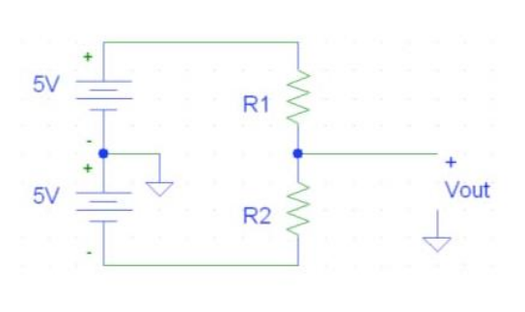

Diagram of Circuit With Parallel Load, Instead with 4 V Power Source:

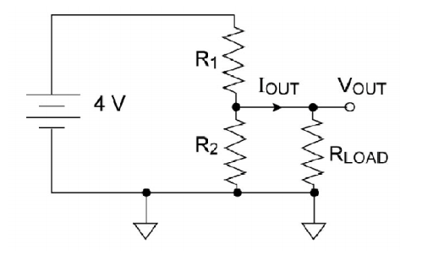

**Analysis:**

**Effects of Parallel Loading on Voltage Divider Performance (Part A4)**

Graph of $V_{out}$ as a function of $I_{out }$ as Parallel Load Decreases

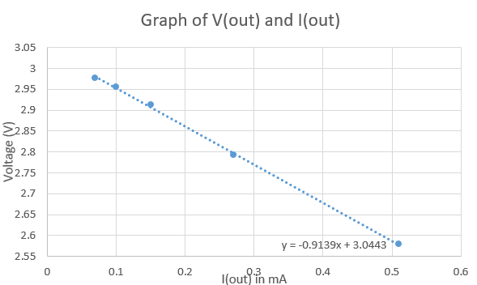

Vout(Iout) = -0.9139(Iout) + 3.0443

1. The Y-intercept in this case is 3.0443, which means that Vout = 3.0443 when Iout = 0
2. Vout decreases as the load increases, Parallel resistors will have a smaller voltage difference as the parallel resistance decreases. This is because in Ohm’s Law, since V = IR, as the total resistance decreases, the voltage output also decreases.
3. Slope = -0.9139, or the resistance load. In this case, for every 1 mA increase, there is a 0.9139 V decrease.
4. Slope can be written in terms of R1, R2, Vout, and Iout:

= Equivalent Resistance of Circuit, $I_{s}$ = total current, $V_{s}$ = total voltage(4V)

= + (

= +

= +

= +

=

=

4. If Vout is limited so that it can only deviate from its open circuit equivalent value by 5%, the Resistor load will a1so be limited. Note that Vout increases (and Iout decreases) as the resistance decreases. In this case, Vout cannot be any lower than its open-circuit value, and RL cannot be any lower than 0Ω. In this case, Iout cannot be lower than 0 mA.

0.05(Vout open circuit) = 0.05 (3V) = 0.0167 V

Vout(Iout) = -0.9139(Iout) + 3.0443

0.0167 = -0.9139(Iout) + 3.0443

-0.9139(Iout) = - 3.061

Iout = 3.3493 mA

$R_{L}=\frac{V_{out open circuit}}{I_{out}}$

$R_{L}=\frac{3 V}{3.2943 mA}$

$R_{L}=910.67 Ω$

Range of $R_{L}:$ 0 $Ω$- 910.67 $Ω$

**O-Scope Data**

**Graph of Square Wave**

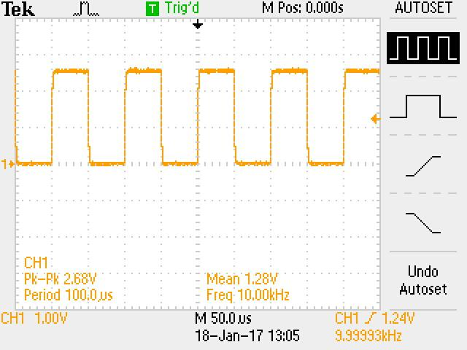

**Graph of Rising Voltage:**

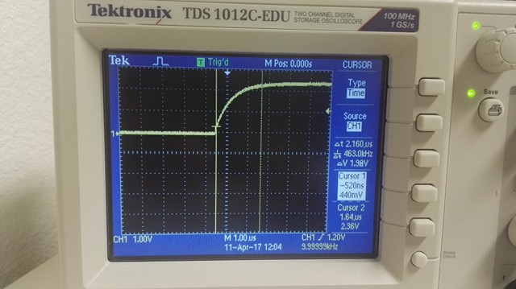

**Graph of Falling Voltage:**

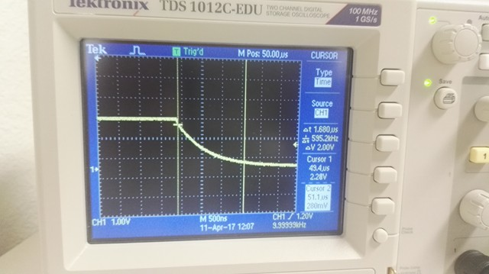

**End of Lab Discussion:**

An ideal voltmeter has infinite resistance. It is equal to an open circuit. Thus, voltmeter has to connect in parallel. An ideal ammeter has zero resistance. Therefore, it serves as a short circuit.

Thus, ammeter needs to be connected in series, so that current does not branch off. As a short circuit has zero voltage and zero resistance, electric current will travel through a circuit area with least resistance. This can be disastrous as not only will the circuit not function properly, but also it will cause enormous amount of current to flow into the part of the circuit. This heats up the circuit wire dramatically, and can potentially cause an electric fire if the current is extremely high. By contrast, an open circuit has infinite resistance and zero current. However, a voltage still exists between the two open circuit terminals. This makes it easy to measure voltage without disturbing other circuit elements. The rise and fall times that were measured in the section B of the lab can be elaborated by the fact that there is a small signal delay in the signal generator between rise and fall signals. This delay is because of the fact that the charges going through the wires from the signal generator to the O-scope takes time due to the small and large resistances.

**Conclusion:**

This lab demonstrated how parallel loading for analog signals as well as delay delay in changes with the rise and fall in output signals. In this lab, we notices that increasing the equivalent resistance will increase the output voltage between the resistors, but at the same time, it decreases the current output. The relationship between these values are linear due to Ohm’s law and the fact that current in this circuit is steady-state. The equivalent resistive load can be thought of as a parameter of the I-V graph. As Vout decreases, the resistive load parameter increases. This is why I and V have a negative linear relationship. Asl larger resistances mean lower currents (as the source voltage is kept constant). theWe also Analyzed the rise and fall times of the voltage output for the digital voltage divider. This type of circuit has a sinusoidal instead of a constant output because the voltage is supplied to the circuit in square pulses at a fixed frequency instead of at a constant voltage output. This lab can be considered a success!